http://www.causewaycoastandglens.com/portals/2/downloads/CCRItineraryGoT3day.pdf

Day 1: Arrive in Dublin, Collect Car
Dublin hop on/off
Welcome to Ireland and to Dublin, the capital City! Upon your arrival in Dublin, make your way to your overnight accommodation. Dublin is the capital of Ireland and one of Europe’s most vibrant cities. Home to over a quarter of the Ireland’s population, almost one million in all, Dublin is a youthful, vibrant and dynamic city with an ever-increasing cosmopolitan influence. Time permitting, we would recommend that you take the Dublin “Hop On, Hop Off” tour – just over one hour this guided tour which lasts all day and allows you explore the history and culture of Dublin at your leisure. An all day ticket means you can hop on and off as often as you wish throughout the day. Join the tour every 30 minutes at any of the 10 bus stops and buy your ticket from the driver. Each stop is located at one of Dublin’s most interesting attractions.
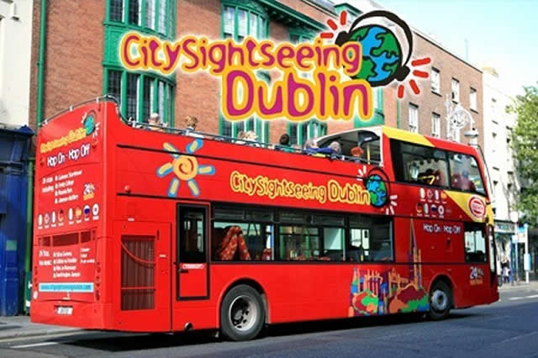
All tours start and end at 59 Upper O’Connell Street, Dublin 1. Tel +353 1 873 4222
Other items to see in Dublin:
Trinity College, The Book of Kells was written around the year 800 AD and is one of the most beautifully illuminated manuscripts in the world. It contains the four gospels, preceded by prefaces, summaries, and canon tables or concordances of gospel passages. It is written on vellum and contains a Latin text of the Gospels in insular majuscule script accompanied by magnificent and intricate whole pages of decoration with smaller painted decorations appearing throughout the text. The manuscript was given to Trinity College in the 17th century and since 1953 has been bound in four volumes. It has been on display in the Old Library since the 19th century. Two volumes can normally be seen, one opened to display a major decorated page, and one to show two pages of script.
St Patrick’s Cathedral is traditionally the site of a holy well used by St Patrick for baptisms and a church was established here as early as the late fifth century – a stone marking the site of the well was found in 1901 after the demolition of buildings nearby to form the park beside the cathedral. The present cathedral was founded in 1192 by Archbishop John Comyn. As Archbishop he resided in the priory of Christ Church Cathedral – unwilling to submit to the jurisdiction of the City Provosts, he started a cathedral and palace outside the city walls.
Guinness Storehouse – The new Guinness Experience is located in the heart of the Guinness brewery in Dublin. It is a dramatic story that begins over 250 years ago and ends in Gravity, the sky bar, with a complimentary pint of Guinness and an astonishing view of Dublin. As you wander up through Guinness Storehouse, you’ll discover what goes into making the Black Stuff- the ingredients, the process, the passion.
Overnight & Breakfast in Dublin
DAY 2: Dublin to Belfast
On arrival to Belfast consider an optional world famous Black Taxi tour of the Falls and Shankill Roads along with murals of troubled times and also the peace wall. Highly recommended by Lonely Planet and all the leading guidebooks! OR Take the free time for lunch and shopping time in Belfast bustling downtown shopping area. Use your free time to explore this magical city. Visit the Crown Liquor Saloon, the Grand Opera House or check out Belfast's own leaning tower “Albert Clock” Loads of time for a tasty and traditional Ulster lunch!
Visit the Titanic Experience! From her conception in Belfast in the early 1900's, through her construction and launch, to her infamous maiden voyage and catastrophic demise. This is one of the world's most famous visitor attractions.
This evening why not join Pub Walking Tours of Belfast you will visit six of Belfast’s most historic pubs, led by a local “pub expert” guide. Visits include Kelly’s Cellars, McHugh’s, The Morning Star, White’s Tavern, The Blackthorn, Duke of York and more. The tour departs from Flannigan’s, upstairs at the Crown Bar, Great Victoria Street.
Overnight & Breakfast in Belfast

DAY 3: Belfast to Glenarm
A sound night’s sleep and a hearty breakfast are the order of the day before setting out from Northern Ireland’s capital city of Belfast along the M2 (branching onto the A2) and on to the famed Causeway Coastal Route. Celebrated as one of The World’s Great Road Journeys, this twisting trail of tar macadam is about to test your stamina for small screen scripts, sights, and sound bites as it takes you to seven mythical kingdoms in one day.
Seven is indeed the magic number for it is only seven miles past Larne, known as gateway to the Glens [of Antrim], that you will come across Cairncastle (near the village of Ballygally). It was here that it all began, so to speak, and where you encounter your first dilemma. It was here on the windswept Antrim Plateau that Game of Thrones kicked off in dramatic fashion with Ned Stark beheading the Night’s Watch deserter, witnessed by Jon Snow, Theon Greyjoy, and the Stark brothers Robb and Bran; and where Catelyn captures Tyrion Lannister whom she suspects of trying to kill her son. When Bran, Rickon, Osha, and Hodor head north to The Wall it is also from the land above Cairncastle that they take a last look back at Winterfell.
However, even the most imaginative scriptwriter would have trouble topping Cairncastle’s own tale of the nobleman supposedly drowned along the coastline in 1588 as part of the ill-fated Spanish Armada. He was laid to rest in St Patrick’s Church graveyard and on the spot where he was buried stands the gnarled and twisted branches of a Spanish chestnut tree. Samples taken from the tree reveal it does indeed date from the 16th century.
From Cairncastle it’s only a few short miles to picturesque Glenarm. With pitched battles between would-be rulers of Westeros a frequent subject matter for Game of Thrones it’s fitting that day one should end in a village whose name is taken from the Irish Gleann Arma, meaning Valley Of The Army. For those with sufficient reserves of energy you can explore Glenarm Castle (seat of the Earls of Antrim for 400 years), the beautiful Glenarm Forest Park, and a workshop that Game of Thrones fans will want to visit. Steensons Jewellery Economusee is where many of the stunning pieces for the series were crafted such as Joffrey’s crown, Lannister lion pendants, stag pins, and silver fish brooches. What’s more you’ll be welcome to watch the craftsmen at their work and perhaps purchase something special for yourself.
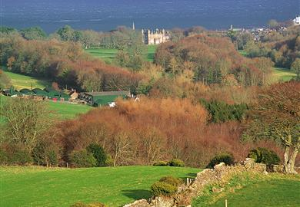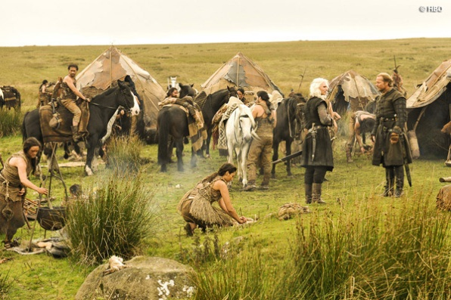
Overnight & Breakfast in Glenarm / Carnlough

DAY 4: Glenarm to Ballycastle
Leaving Glenarm you travel inland once more for just under 10 miles until you reach the Shillanavogy Road in the shadow of Slemish Mountain. St Patrick, Ireland’s patron saint, tended sheep on Slemish after being brought to the area by pirates who slaughtered his family. It’s the sort of barbarism that would no doubt have found favour with the warlike Dothraki horde and an appropriate setting for the Game of Thrones scenes where Daenerys Targaryen, Ser Jorah Mormont, and the Dothraki horsemen ride through the grasslands en route to Vaes Dothrak. From the splendid isolation of Slemish through the village of Broughshane, famed for its vibrant floral displays, it’s time to head back towards the coast and the beautiful villages of Cushendall and Cushendun. It was in the caves at Cushendun, easily accessible on foot, that the Game of Thrones crew filmed the dramatic scene from Season Two in which Davos Seaworth, on the orders of Lord Stannis, takes the sorceress Melisandre ashore where she gives birth to a shadowy baby. From Cushendun it’s on to the magnificent Murlough Bay with its views of Rathlin Island, Mull of Kintyre, and the Scottish Islands. Used as the road to Pyke on which Theon Greyjoy and his sister Asha ride on horseback, it was a location close to the heart of Michelle Fairley (Lady Stark). “I was particularly pleased when I heard Game of Thrones was going to be filming at Murlough Bay. I used to go swimming there as a child.”
Ballycastle, birthplace of Game of Thrones star Conleth Hill (Varys), will be the last port of call on day two, but first you must pass through the coastal town for one more location of jaw-dropping natural beauty.
Larrybane, meaning ‘the ancient white site’, is classic Storms End with its panoramic views of the limestone cliffs and ocean. It hosted several key scenes, including where Brienne beats Ser Loras in a tourney and is given a place in Renly’s Kingsguard as a reward. At Larrybane Renly also swears to Lady Stark that he will avenge Ned’s death, but meets his end at the hands of Melisandre’s shadow baby; Margaery confides to Littlefinger (following Renly’s death and with Stannis’ fleet off-ashore) that she wants to be Queen; and Davos tries to tell Stannis what he witnessed in the cave with Melisandre. Stand on Larrybane Head with the wind in your hair, look out to sea, and you will also truly understand why Game of Thrones came here, and why the programme makers chose this view for their generic panning shots of the coast. However, if you really want to test your head for heights why not take time out and visit nearby Carrick-a-Rede Rope Bridge. One of Northern Ireland’s most famous landmarks, the bridge is suspended across a 20-metre chasm between the mainland and the tiny Carrick Island, with a 23-metre drop to the water below. Cross Carrick-a-Rede and you will have earned a hearty meal and a glass of Dornish wine when you return for the night to Ballycastle.
Overnight & Breakfast in Ballycastle/Portrush

Day 5: Ballycastle – Londonderry
With the winding road hugging the coastline and the Atlantic Ocean your constant companion the first stop on day three is the hidden gem that is Ballintoy Harbour. Still a working harbour for local fishermen, Ballintoy doubled as Lordsport Harbour (The Iron Islands) and the homecoming of Theon Greyjoy after ten years in Winterfell. The beach at Ballintoy is where Theon was baptized into the faith of the ‘Drowned God’, cementing his return to the House of Greyjoy. Continue along Whitepark Road for just under four miles and you will see signs for Dunseverick, another of the myriad wonderful little harbours and inlets that populate the area. There was little sign of brotherly love but a huge helping of sibling rivalry when Renly and Stannis met here to discuss their claims to the Iron Throne. It was also Renly’s first encounter with the ‘fire priestess’. Filming may not have taken place at the Giant’s Causeway(although the sea beyond featured in several sweeping shots) but no visit to the Causeway Coast and Glens would be complete without calling in at the UNESCO World Heritage Site with it’s unique six-sided basalt columns and the wonderful local legend that is Finn McCool As you reach the village of Bushmills (site for one of the Ireland’s oldest whiskey distilleries) you will be lured inland to one of the most photographed natural phenomenon in the region, the haunting (and we mean haunting) avenue of trees near Armoy known as ‘The Dark Hedges’. This is where Arya Stark, dressed as a boy, escaped from King’s Landing.
Overnight & Breakfast in Derry

DAY 6: Londonderry to Dublin
We would recommend that you take a tour of the Boyne Valley in North Dublin on your return to Dublin. The Boyne Valley and its surroundings, situated some 20 miles north-west from Dublin, is one of the most important Irish locations as far as historical heritage is concerned, from pre-celtic to medieval times. In this area you can find the pre-celtic tumula of Newgrange, Knowth and Dowth, the Hill of Tara, where the ancient Irish kings settled their kingdom (actually, there is not much to see in Tara nowadays, but the site is inspiring), Monasterboice with its High Crosses, the Mellifont Abbey, and many other interesting things. Take the N2 heading north via Ashbourne towards Slane in Co. Meath. Turn right about 2km south of Slane, the Brú na Bóinne Visitor Centre is 7km (4.5 miles) east towards the village of Donore. For about 3km before the Visitor Centre the road follows the bend in the river Boyne. Brú na Bóinne Visitor Centre, open in 1997, is designed to present the archaeological heritage of the Boyne Valley, which includes the megalithic passage tombs of Newgrange and Knowth. The Centre is the starting point for all visits to both monuments, and contains extensive interpretative displays and viewing areas.Please note that this is a very busy site and visitors must expect a delay in the summer months if visiting Newgrange and Knowth and access is not guaranteed.
Return to Dublin.
Overnight & Breakfast in Dublin

Day 7 – Dublin
Shopping
The main shopping areas are Nassau Street, Grafton Street, St. Stephen’s Green, Temple Bar, O’Connell Street and Henry Street. The department stores are on Grafton Street (Brown Thomas, excellent for Irish fashion design has now relocated to the former Switzers building) and in O’Connell Street (Clery’s, for the more budget-conscious). For Irish and European gifts try House of Ireland on Nassau Street. Shopping malls include the St. Stephen’s green shopping centre, the largest in the city, which is a bright and spacious shopping area where you can buy just about anything and also have a meal (it can be very crowded, especially in summer). The Powerscourt Townhouse on Clarendon Street (follow the sign on Grafton street) is on a smaller scale and specialises in wonderful restaurants, cafes, crafts, jewellery and clothes stores.
On the other side of Grafton street in Dawson street is the royal Hibernian way, a small shopping mall with some very exclusive clothes shops. Finally, there is the Jervis Centre which is second only to St Stephen’s green. Here you will find many clothes stores for all ages and a large branch of Dunnes Stores, an Irish clothes and food shop chain. Branches of Marks and Spencers can be found in Grafton Street and Henry street, where most of the larger chain stores are represented, including the body shop for natural beauty products, HMV for music and concert tickets and the Levis store for casual clothing.
This evening we would recommend that you dine in the famous “Temple Bar” area of Dublin city. Since 1991, it become the cultural and entertainment quarter of the city (currently with 11 hotels and hostels. 14 music venues, 21 bars and 74 eating places!), Temple Bar covers 28 acres (11.3 hectares) and is bounded by Dame Street, Fishamble Street, the South Quays of the River Liffey and Westmoreland Street. The pubs of Dublin are not simply places in which to satisfy your thirst. They are theatres for storytelling, backdrops for romance, homes away from home and keepers of the spirit of the city, in more ways than one. It never rains ina pub either! Don’t forget to try a pint of the black stuff (Guinness) but remember it takes a while to become accustomed to the taste!
For your final evening in Ireland, why not take in a visit to the Shindig night at the Old Jameson Distillery Your evening begins with a drinks reception and guided tour of the distillery. Guests may also join a whiskey tasting session. This relaxed evening includes Irish music and “craic” and also contemporary “Riverdance” style dancing, paired with a delicious meal.
Overnight and Breakfast in Dublin

Day 8
Return Flight

